Introduction
This test program intends to demonstrate the seal performance under site conditions after several reports of failure and inconsistency of leakage.
The subject of this testing is mechanical seal order 950969 modified. This version of mechanical seal was designed based on new seal faces geometry to include lasered wavy face technology.

Test N°4 – (Sep 19 – Sep 22, 2023)
This test will be performed with same faces from test 03 without lapping or re-conditioning.
Barrier fluid will be simulated as per site conditions Water.
The pressure during this test will be increase to 113barg simulating original site conditions.

Seal Configuration
Seal faces
 | Part Drawing | Material | Face condition
Sleeve (1) | C0619166NL | Alloy C-276 | From Test 03
Inner Seal Stator (14) | C0618722SL | Silicon Carbide (SL) | From Test 03
Inner Seal Rotor (15) | C0619339SL | Silicon Carbide (SL) | From Test 03
Outer Seal Stator (14.1) | C0618722SL | Silicon Carbide (SL) | From Test 03
Outer Seal Rotor (15.1) | C0618723SL | Silicon Carbide (SL) | From Test 03

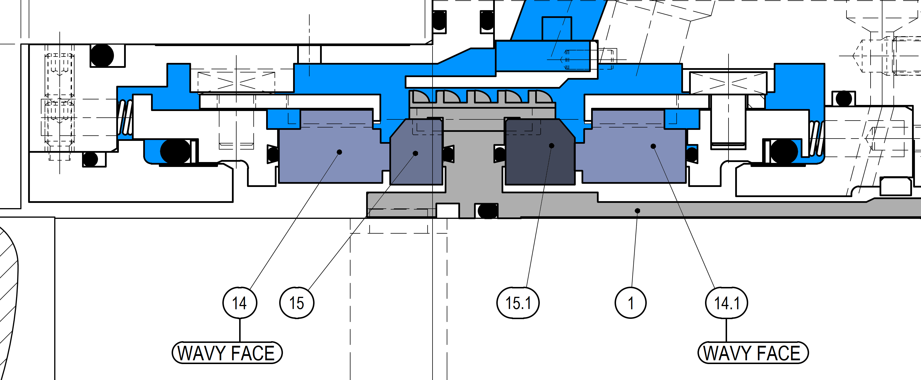
Cross Section of The New Parts

Test Conditions & Results
 | Job seal barrier
Duration | 69.5 hrs
Speed | 2950 rpm
Fluid | Water
Pressure | 113 barg
Inlet temp. | 41 °C
Outlet temp. | 44 °C
Inner Seal Leakage | Avg. 16.9 ml/h
Outer Seal Leakage | Avg. 25 ml/h
Flow | 13.2-12.2 l/min

Tester Drawing D0571813
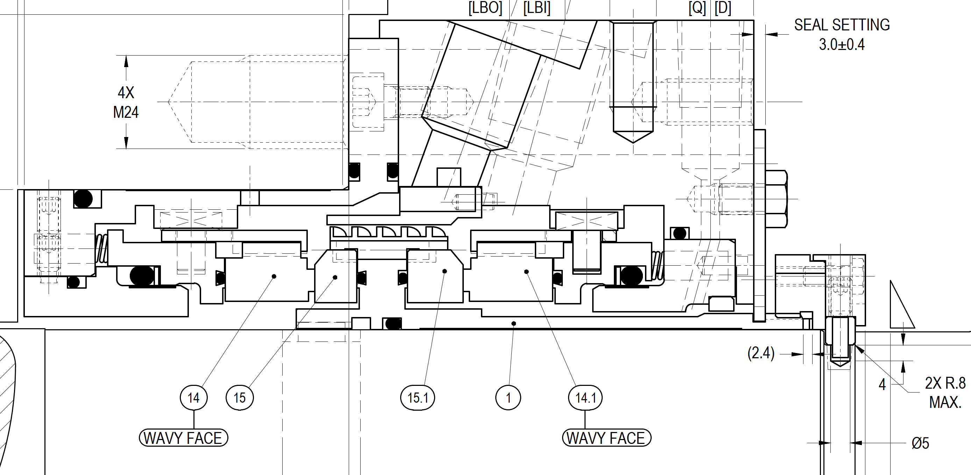

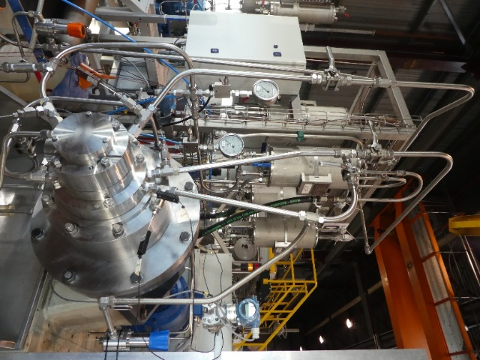
Tester unit B
Logged Data
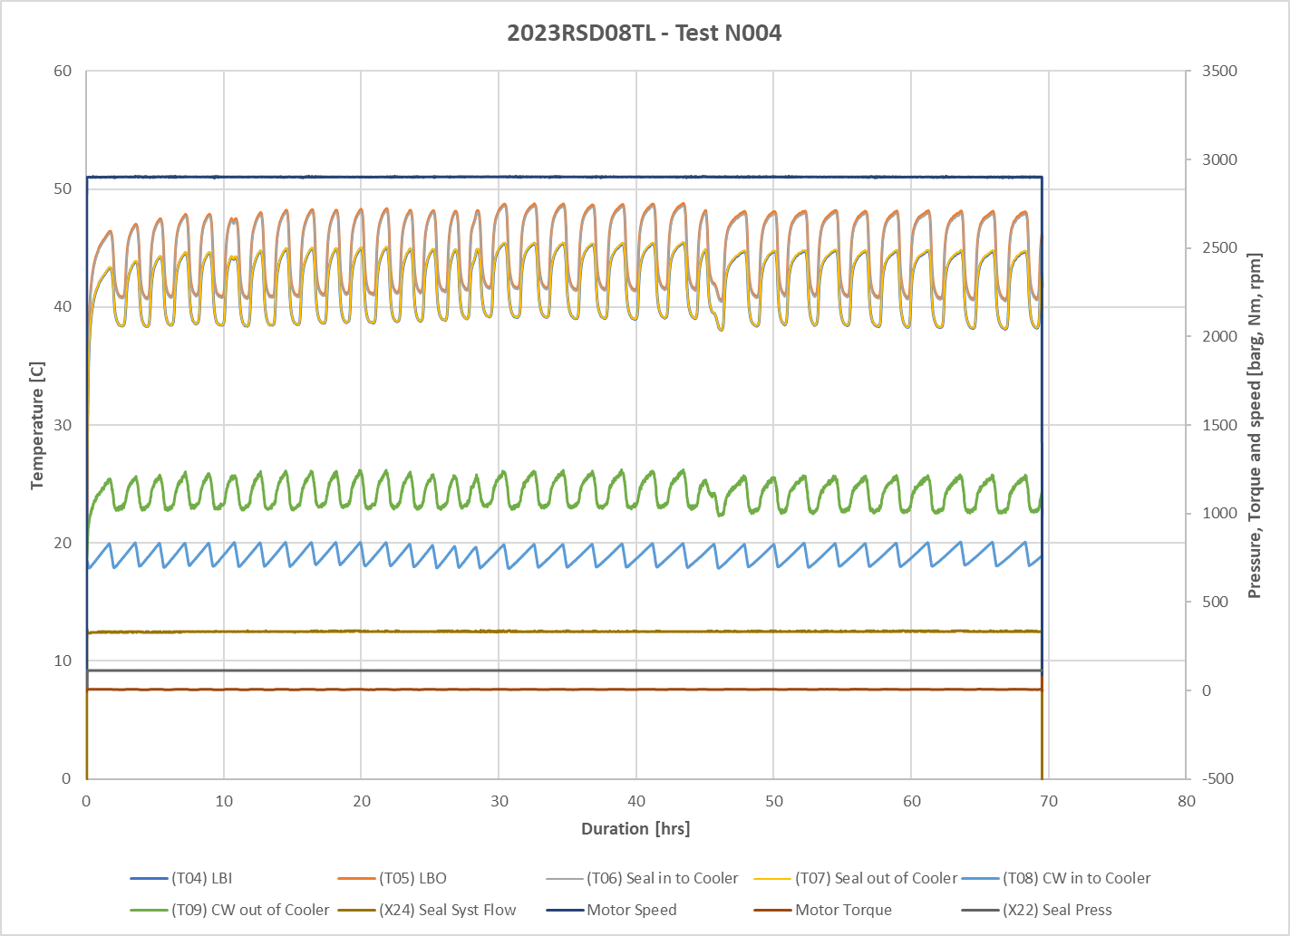

All parameters were stable during the test (temperature, pressure, and leakage)
Leakage was steady during the whole testing period.
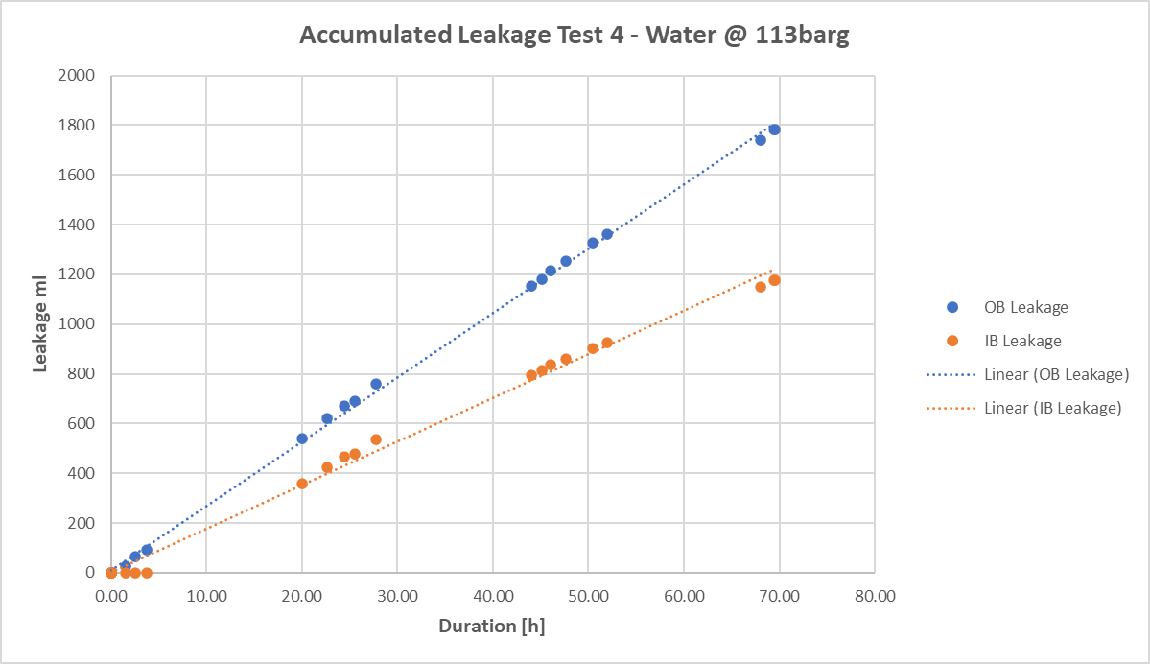

Manually Logged Data
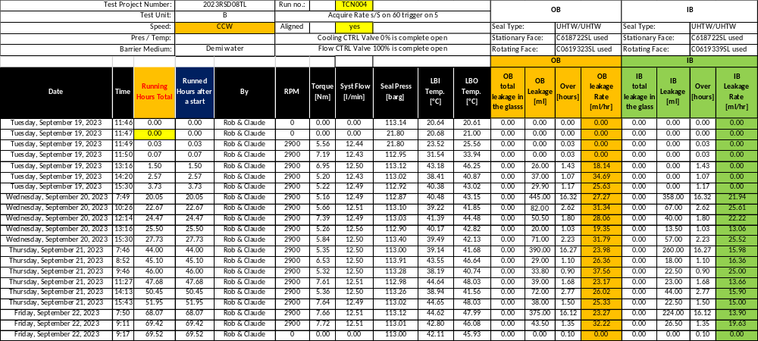

Measurements Results
Leakage rate
 | Inner Seal | Outer Seal
Total Run time [h] | 69.5 | 69.5
Total Seal Leakage [ml] | 1176 | 1781.7
Seal Leakage Rate [ml/h] | 16.5 | 25

Post-Test Pictures
IB Rotor | IB Stator
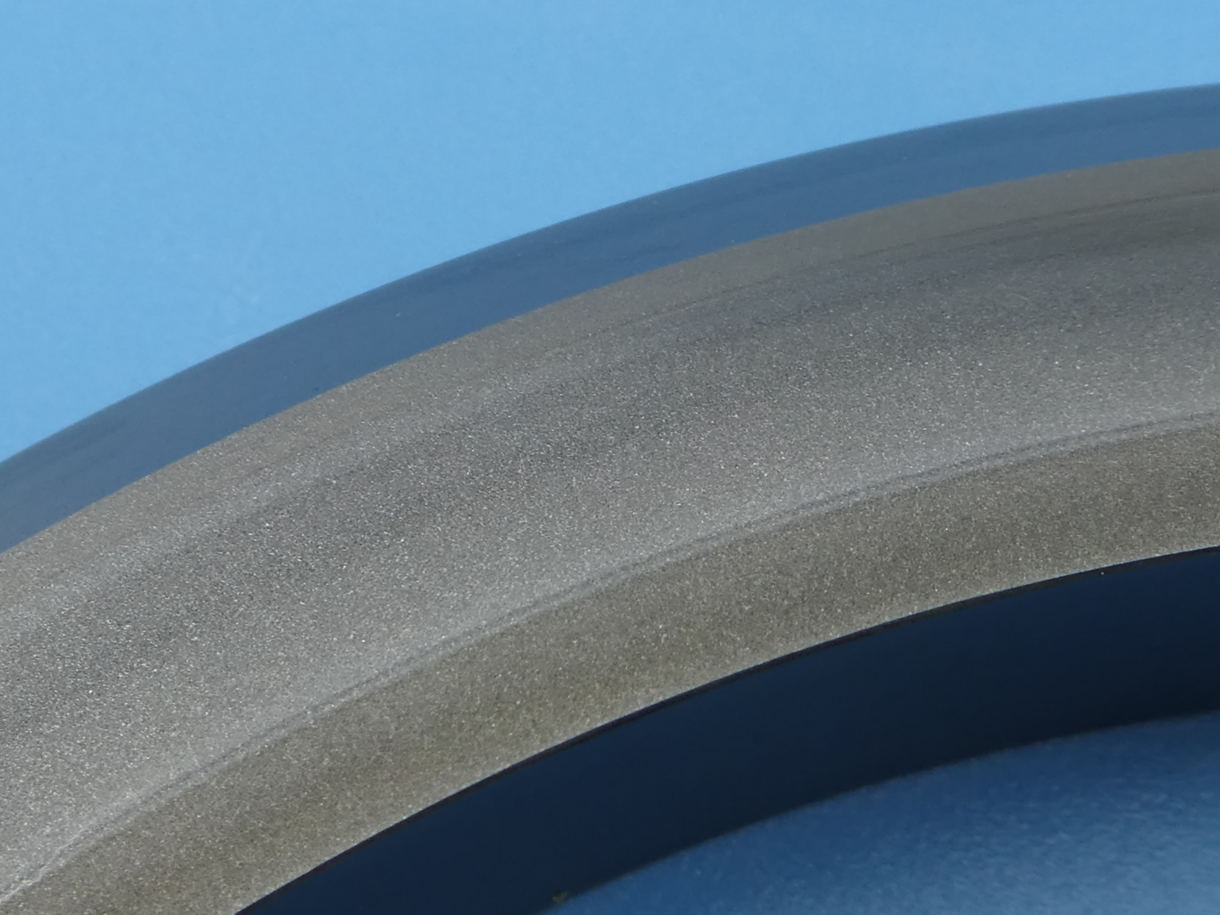 | 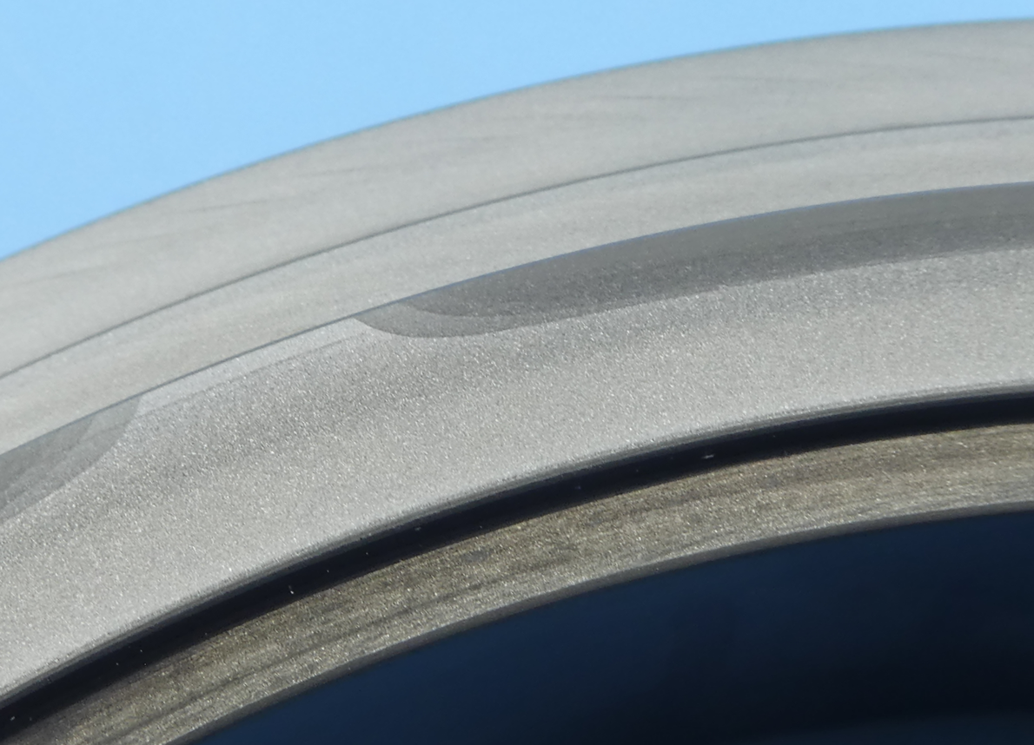
Ra | Ra

OB Rotor | OB Stator
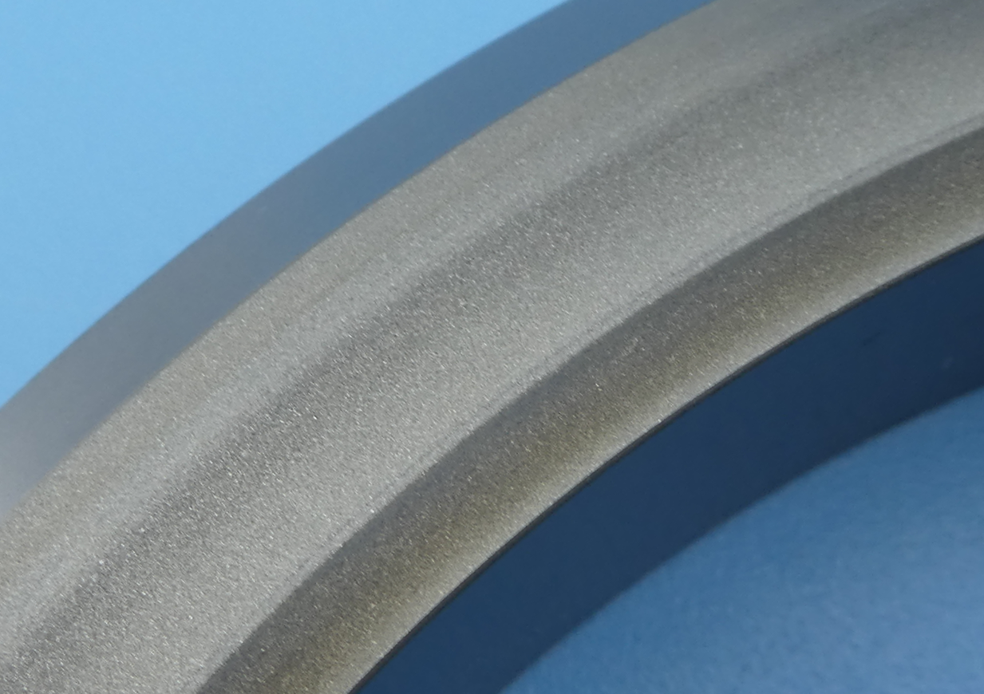 | 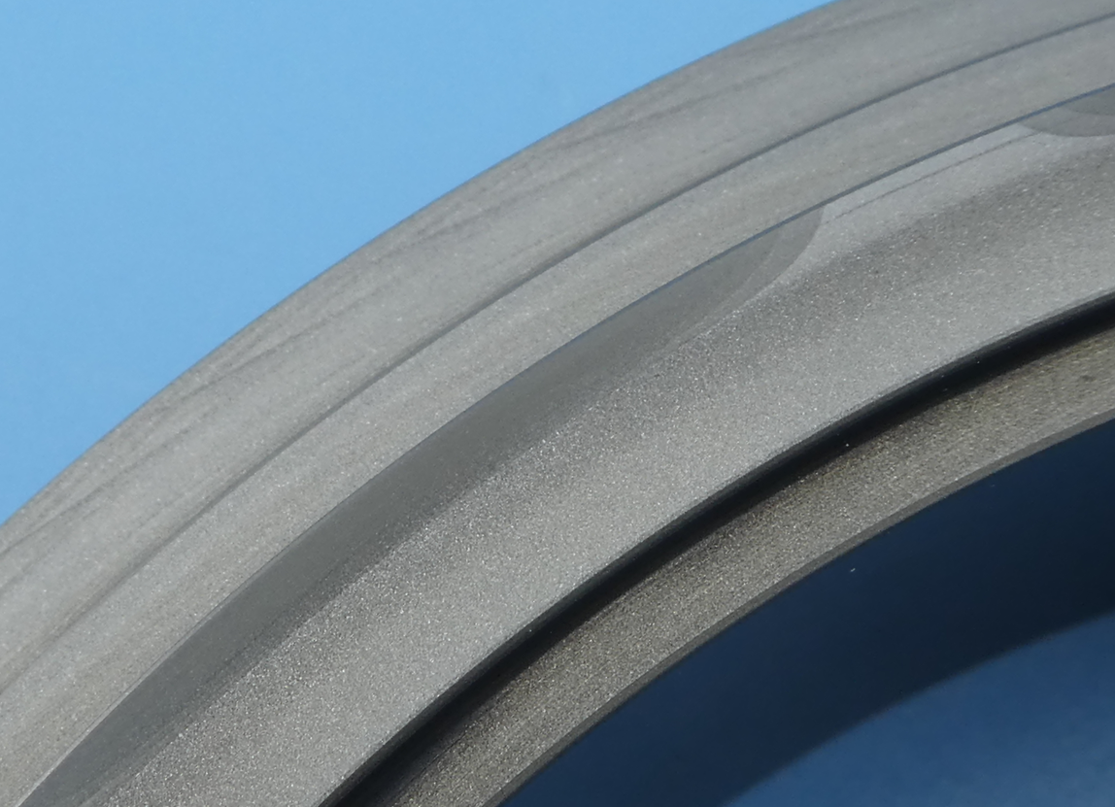
Ra | Ra

Test Conclusion
The third test results showed very stable seal performance using water, the leakage was low and within acceptable limits.
Seal faces didn’t show any damage or deterioration for the duration of the test exceeding 144h. This conclude that seal faces are suitable for water and 113barg.

